Open anaconda prompt: check python version:

python –-version

conda info

Open cmd install pip: install the following modules

curl https://bootstrap.pypa.io/get-pip.py -o get-pip.py

python get-pip.py

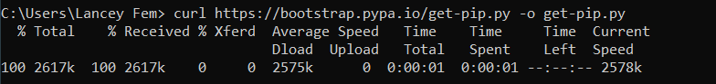

Install flask

pip install flask

pip install flask-login

pip install flask-sqlalchemy #for data base

set up flask in the __init__.py

if there’s an error that flask is not found:

ctrl+shift+p > python select interpreter = select a python interpreter